**Name:** Deepanshu Miglani **SAP ID:**500106264  **BTech CSE AIML B4(NH)**

**Lab 1**

**Q1. Write a Python program to perform basic arithmetic operations (addition, subtraction, multiplication, division, and modulus) on two numbers.**

* Prompt the user to enter two numbers.
* Perform the arithmetic operations and print the results.
* Use appropriate operators and print formatting for clear output.

**CODE:**

num1 = float(input("Enter the first number: "))

num2 = float(input("Enter the second number: "))

addition = num1 + num2

subtraction = num1 - num2

multiplication = num1 * num2

division = num1 / num2 if num2 != 0 else "Undefined (cannot divide by zero)"

modulus = num1 % num2 if num2 != 0 else "Undefined (cannot divide by zero)"

print("\nResults:")

print(f"Addition: {num1} + {num2} = {addition}")

print(f"Subtraction: {num1} - {num2} = {subtraction}")

print(f"Multiplication: {num1} * {num2} = {multiplication}")

print(f"Division: {num1} / {num2} = {division}")

print(f"Modulus: {num1} % {num2} = {modulus}")

**OUTPUT:**

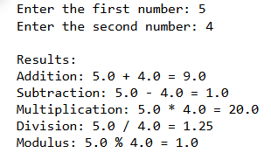

**Q2.  Create variables of different data types (integer, float, string, boolean) and perform basic operations on them.**

* Assign values to variables of different data types.
* Perform arithmetic operations on numeric data types.
* Concatenate strings using the + operator.
* Use logical operators to evaluate boolean expressions.

**CODE:**

integer_var = 10 # Integer

float_var = 20.5 # Float

string_var = "Hello" # String

boolean_var1 = True # Boolean

boolean_var2 = False # Boolean

sum_result = integer_var + float_var

difference_result = integer_var - float_var

product_result = integer_var * float_var

division_result = float_var / integer_var

concatenated_string = string_var + " World!"

logical_and = boolean_var1 and boolean_var2

logical_or = boolean_var1 or boolean_var2

logical_not = not boolean_var1

print("Arithmetic Operations on Numeric Data Types:")

print(f"Sum: {integer_var} + {float_var} = {sum_result}")

print(f"Difference: {integer_var} - {float_var} = {difference_result}")

print(f"Product: {integer_var} * {float_var} = {product_result}")

print(f"Division: {float_var} / {integer_var} = {division_result}")

print("\nString Concatenation:")

print(f"Concatenated String: \"{string_var}\" + \" World!\" = \"{concatenated_string}\"")

print("\nBoolean Expressions:")

print(f"Logical AND (True and False): {boolean_var1} and {boolean_var2} = {logical_and}")

print(f"Logical OR (True or False): {boolean_var1} or {boolean_var2} = {logical_or}")

print(f"Logical NOT (not True): not {boolean_var1} = {logical_not}")

**OUTPUT:**

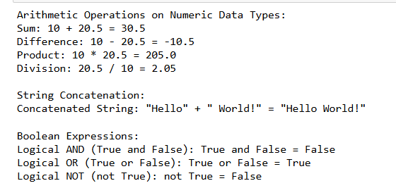

**Q3. Write a program to take user input, process it, and display the result.**

* Prompt the user to enter their name.
* Greet the user using their name.
* Calculate and print the user's age based on their birth year.

**CODE:**

name = input("Enter your name: ")

print(f"Hello, {name}!")

birth_year = int(input("Enter your birth year: "))

current_year = 2024 # Update this to the current year if needed

age = current_year - birth_year

print(f"{name}, you are {age} years old.")

**OUTPUT:**

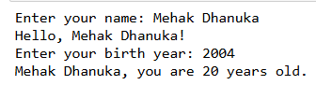

**Q4.  Write a program to check if a number is even or odd.**

* Prompt the user to enter a number.
* Use the modulus operator to determine if the number is even or odd.
* Print the appropriate message.

**CODE:**

number = int(input("Enter a number: "))

if number % 2 == 0:

print(f"The number {number} is even.")

else:

print(f"The number {number} is odd.")

**OUTPUT:**



**Q5. Write a program to print the numbers from 1 to 10 using both for and while loops.**

* Use a for loop to iterate through a range of numbers.
* Use a while loop with a counter variable.

**CODE:**

print("Numbers from 1 to 10 using for loop:")

for i in range(1, 11):

print(i, end=" ")

print()

print("\nNumbers from 1 to 10 using while loop:")

counter = 1

while counter <= 10:

print(counter, end=" ")

counter += 1

print()

**OUTPUT:**

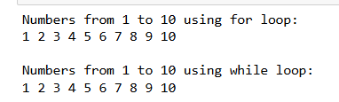

**Q6.  Create a list, access elements, modify elements, and perform list operations.**

* Create a list of fruits.
* Access elements using indexing.
* Modify elements in the list.
* Add and remove elements from the list.
* Find the length of the list.
* Sort the list in ascending and descending order.

**CODE:**

fruits = ["Apple", "Banana", "Cherry", "Mango", "Orange"]

print("Accessing elements:")

print(f"First fruit: {fruits[0]}")

print(f"Third fruit: {fruits[2]}")

fruits[1] = "Blueberry"

print("\nModified list:", fruits)

fruits.append("Pineapple")

fruits.insert(2, "Strawberry")

print("\nList after adding elements:", fruits)

fruits.remove("Mango")

popped_fruit = fruits.pop()

print("\nList after removing elements:", fruits)

print(f"Removed fruit: {popped_fruit}")

length_of_list = len(fruits)

print(f"\nLength of the list: {length_of_list}")

fruits.sort()

print("\nList sorted in ascending order:", fruits)

fruits.sort(reverse=True)

**OUTPUT:**

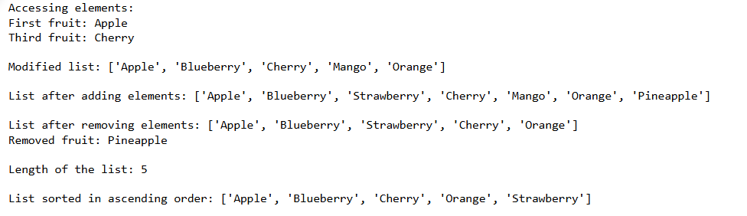

**Q7. Manipulate strings using various built-in functions.**

* Create a string variable and find the length of the string.
* Convert the string to uppercase and lowercase.
* Check if a substring exists in the string.
* Split the string into a list of words.

**CODE:**

text = "Hello, welcome to the world of Python programming!"

length_of_string = len(text)

print(f"Length of the string: {length_of_string}")

uppercase_string = text.upper()

print("\nString in uppercase:", uppercase_string)

lowercase_string = text.lower()

print("String in lowercase:", lowercase_string)

substring = "Python"

if substring in text:

print(f"\nThe substring '{substring}' exists in the string.")

else:

print(f"The substring '{substring}' does not exist in the string.")

words_list = text.split()

print("\nList of words:", words_list)

**OUTPUT:**

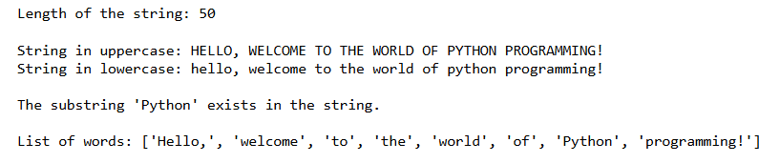

**Q8. Write a program to find the largest and smallest number in a list.**

**CODE:**

numbers = [34, 12, 78, 56, 89, 23, 67, 45]

largest_number = max(numbers)

smallest_number = min(numbers)

print(f"List of numbers: {numbers}")

print(f"Largest number: {largest_number}")

print(f"Smallest number: {smallest_number}")

**OUTPUT:**

